 | 
OptiCrop: Smart Agricultural Production Optimization Engine
Project Description:
OptiCrop harnesses data-driven machine learning to help farmers, researchers, and policymakers make smarter agricultural decisions. The platform integrates key environmental factors — Nitrogen (N), Phosphorous (P), Potassium (K), soil temperature, humidity, pH, and rainfall — to recommend the most suitable crop for a given field, or to assess whether an existing field is suitable for a crop the user already has in mind.
The system is built around a trained classification model (Scikit-learn) served through a Flask REST API. Users submit soil and climate readings through a simple web form; the backend validates the input, runs it through the trained model, and returns a ranked crop recommendation along with a confidence score. A companion suitability-assessment feature lets users check a specific crop against their current field conditions, and a lightweight visualization dashboard surfaces trends across submissions for research and policy use cases.
Scenarios
Scenario 1: A farmer enters soil and environmental details such as Nitrogen (N), Phosphorous (P), Potassium (K), temperature, humidity, pH level, and rainfall. The system analyzes the data and recommends the most suitable crop for maximum yield and better farming efficiency.
Scenario 2: A user wants to understand whether the current soil and climate conditions are suitable for a particular crop. The application evaluates the input parameters and provides insights about crop compatibility, environmental suitability, and productivity potential.
Scenario 3: An agricultural researcher or policymaker uses the system to analyze crop-environment relationships and identify patterns in agricultural production. The platform helps in making data-driven decisions for sustainable farming strategies and resource optimization.
Technical Architecture:
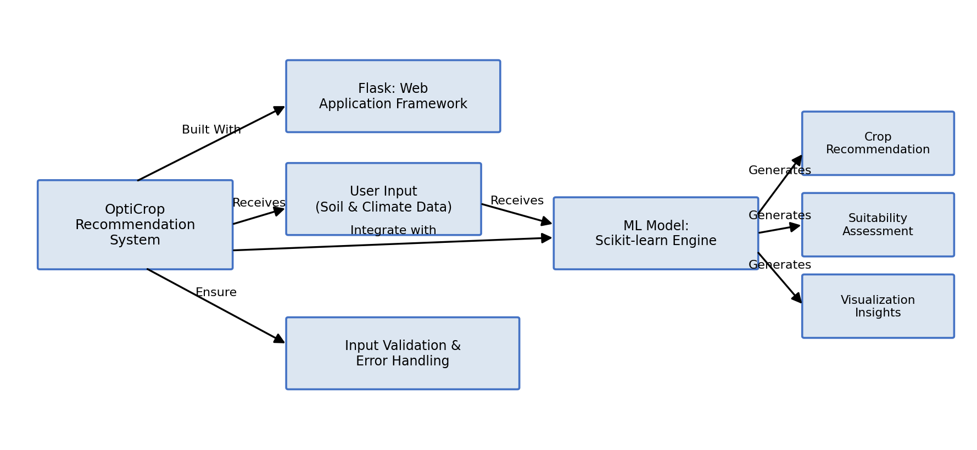
Description: OptiCrop uses a modular three-tier architecture. A Flask-based backend receives soil and environmental readings from the user, validates them, and forwards them to a Scikit-learn classification model trained on historical crop-environment data. The model generates a crop recommendation, a suitability assessment, and the underlying data that feeds the visualization dashboard. Secure input validation and error handling wrap every stage of the pipeline.
(Note: OptiCrop does not use a persistent database in its current version — the model is trained offline from a CSV dataset and loaded into memory at startup. If a database is added in a future version (e.g., to store user submission history), an ER diagram should be added here along with a description.)
Pre-requisites:
- Flask Framework Knowledge: Flask Documentation
- Scikit-learn Familiarity: Scikit-learn Documentation
- Data Handling with Pandas & NumPy: Pandas Documentation
- Data Visualization: Matplotlib Documentation
- Python Programming Proficiency: Python Documentation
- Version Control with Git: Git Documentation
- Development Environment Setup: Flask Installation Guide
Project Workflow:
Milestone 1: Data Collection and Model Selection
- Activity 1.1: Source and clean a crop-environment dataset containing N, P, K, temperature, humidity, pH, rainfall, and the corresponding crop label.
- Activity 1.2: Research and compare classification algorithms (Random Forest, Decision Tree, SVM, k-NN) for crop prediction accuracy.
- Activity 1.3: Define the application architecture, detailing interactions between the frontend, Flask backend, and the ML model.
- Activity 1.4: Set up the development environment, installing Flask, Scikit-learn, Pandas, NumPy, Matplotlib, and Seaborn.
Milestone 2: Core Functionalities Development
- Activity 2.1: Develop the core features: Crop Recommendation Engine, Crop Suitability Assessment, and the Visualization Dashboard.
- Activity 2.2: Implement the Flask backend to manage routing and input processing, ensuring smooth interaction with the trained model.
Milestone 3: app.py Development
Milestone 3 focuses on the core logic of app.py, the backbone of the OptiCrop application. Routes are defined for the home page, crop prediction, and suitability assessment; input is validated and passed to the trained model; and the JSON response is structured for the frontend.
Define the Core Routes in app.py:
- / — Home page route that renders the main index.html interface.
- /predict — POST endpoint that accepts soil and climate readings as JSON, runs the trained model, and returns the recommended crop with a confidence score.
- /suitability — POST endpoint that accepts a selected crop plus field readings and returns a suitability assessment.
@app.route("/")
def index():
return render_template("index.html")

@app.route("/predict", methods=["POST"])
def predict():
data = request.get_json()
features = [data.get(k) for k in ["N", "P", "K", "temperature", "humidity", "ph", "rainfall"]]
if any(f is None for f in features):
return jsonify({"error": "All soil and climate fields are required."}), 400
try:
prediction = model.predict([features])[0]
confidence = float(max(model.predict_proba([features])[0]))
return jsonify({"success": True, "recommended_crop": prediction, "confidence": confidence})
except Exception as e:
return jsonify({"error": f"Prediction failed: {str(e)}"}), 500

Model Loading & Preprocessing:
- The trained model (crop_model.pkl) and the fitted scaler are loaded once at application startup using joblib, avoiding reload overhead on every request.
- A validators.py module checks that each input value falls within a realistic agronomic range (e.g., pH between 3.5 and 9.5) before it reaches the model.
Milestone 4: Frontend Development
Milestone 4 focuses on a clean, form-driven interface for OptiCrop. The layout is built with HTML and CSS and uses lightweight JavaScript to submit readings asynchronously and render the recommendation, suitability result, or dashboard charts without a full page reload.
- Input Section: A form for entering N, P, K, temperature, humidity, pH, and rainfall, with client-side range validation before submission.
- Results Section: Displays the recommended crop, the model's confidence score, and — for the suitability scenario — a compatibility summary for the crop the user selected.
- Dashboard Section: Renders Matplotlib/Seaborn-generated charts summarizing crop-environment patterns for the research and policy-planning scenario.
Milestone 5: Deployment
- Activity 5.1: Prepare the application for local deployment: create a virtual environment, install dependencies from requirements.txt, and configure the trained model path.
- Activity 5.2: Run the Flask application locally (python app.py) and verify the /predict and /suitability endpoints with sample inputs covering each supported crop.
Milestone 6: Conclusion
Exploring the Website’s Web Pages:
Home / Input Page:
[Insert screenshot of the OptiCrop input form here]
Description: The landing page presents a single form where the user enters soil and environmental readings (N, P, K, temperature, humidity, pH, rainfall) and chooses a scenario — crop recommendation or suitability assessment for a specific crop — before submitting.
Results / Dashboard Page:
[Insert screenshot of the recommendation results and dashboard here]
Description: Revealed after submission, this section displays the recommended crop with its confidence score (or the suitability verdict for the selected crop), alongside a visualization panel showing relevant environmental trends for research and policy analysis.
Conclusion:
OptiCrop is a machine-learning-driven platform built with Flask and Scikit-learn that turns raw soil and climate readings into actionable crop guidance. It supports three core use cases — crop recommendation for farmers, suitability assessment for a chosen crop, and pattern analysis for researchers and policymakers — through a single, validated data pipeline. The project, which spanned model selection, backend and frontend development, and local deployment, demonstrates how a focused ML model paired with a simple web interface can support more sustainable and efficient farming decisions. Looking ahead, OptiCrop has room to grow: adding a persistent database to track submission history, expanding the training dataset with regional soil data, and introducing multi-language support would broaden its usefulness for farmers and policymakers across different regions.

